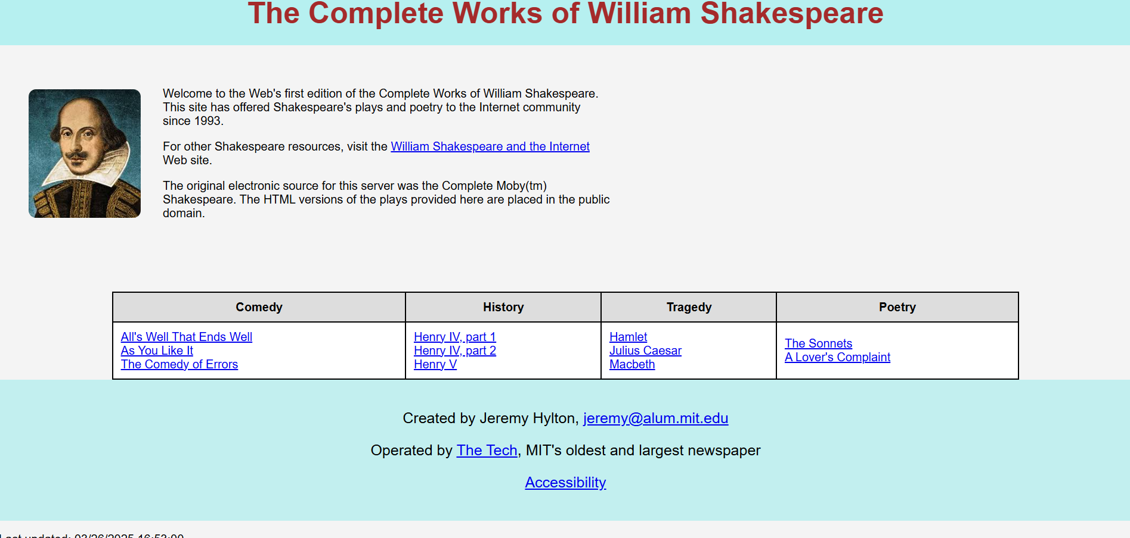

**Addendum:**

1. Font **Choices**:
   * I selected Arial, sans-serif for the body text because it's a clean and modern sans-serif font that is easy to read on digital screens. It provides a straightforward and professional look, suitable for this type of informational page.
   * The title of the page (<h1>) uses a bold, larger font size to stand out and capture attention immediately. The color brown was chosen for the title as it complements the page's overall light and neutral color scheme while maintaining a sense of elegance.
2. **Font Sizes**:
   * The main title <h1> has a font size of 40px to give it prominence. It serves as the most important element of the page and should be the first thing a user notices.
   * Subheadings (e.g., sections like "Comedy," "History," "Tragedy," etc., in the table) are given a default size through the body's font settings, but specific styling is added to table headers (<th>) for clarity and visual hierarchy.
   * The paragraph text (<p>) is set to a comfortable size of 16px for readability. This is a standard web practice, ensuring that the text is neither too large nor too small for easy reading.
3. **Color Choices**:
   * The background color of the page is set to #f4f4f4 (a very light gray), providing a soft backdrop that is easy on the eyes. This ensures that the content is the focal point and not the background.
   * The heading background is a soft blue (#b6f0f0), providing a subtle contrast without being too harsh. This color was chosen to invoke a sense of calm and professionalism.
   * Text colors are kept simple and readable, with the main body text in a dark gray (#333), ensuring good contrast with the background. The headings use brown (#8B4513) for a warm, approachable feel while maintaining readability.
4. **Margin and Padding Choices**:
   * I applied padding to the body to ensure that the content does not touch the edges of the screen, making it easier to read and more visually appealing.
   * The header (<h1>) has padding to give it ample space on all sides, making it appear centered and well-spaced.
   * Each section within the .content div has sufficient space between the image and text, ensuring that the content does not feel cramped and is easy to follow.
   * Table cells have padding to ensure that the text within them doesn't touch the cell borders, which improves the table's readability and aesthetic appeal.
   * I added margins around the table and footer to keep everything spaced well apart, preventing any elements from crowding the edges of the page.
5. **HTML Abuse**:
   * Initially, I used a <div class="header"> to display the page title "The Complete Works of William Shakespeare." This was done purely for visual purposes, but it is semantically incorrect. The title of the page should be marked as an <h1> tag, as it represents the main heading of the page. I corrected this by replacing the <div class="header"> with an <h1> tag to maintain proper HTML semantics.
   * This change improves both the accessibility of the page and its structure, as headings provide better context to search engines and screen readers, ensuring that the page content is presented in a clear, logical order.